Directions: Sketch the graphs of the following rational functions.
Linear Factorization:$f(x)=$

H.A. @ y = __________

S.A. @ y = __________

Discont. @ x = ________

V.A. @ x = __________

Linear Factorization:$g(x)=$

H.A. @ y = __________

S.A. @ y = __________

Discont. @ x = ________

V.A. @ x = __________

$f(x)=\frac{x^{2}+x−2}{x^{2}−x−6}$ $g(x)=\frac{x^{2}−x}{x+1}$

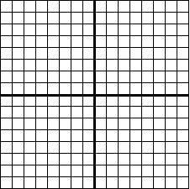

$$f(x)=\frac{x^{3}−3x^{2}−9x−5}{x^{2}−x−2}$$

$$g(x)=\frac{2x^{2}+2x−\text{12}}{x^{2}−x−6}$$

Linear Factorization:

$$f(x)=$$

H.A. @ y = __________

S.A. @ y = __________

Discont. @ x = ________

V.A. @ x = __________

Linear Factorization:

$$f(x)=$$

H.A. @ y = __________

S.A. @ y = __________

Discont. @ x = ________

V.A. @ x = __________

Linear Factorization:

$$f(x)=$$

H.A. @ y = __________

S.A. @ y = __________

Discont. @ x = ________

V.A. @ x = __________

$h(x)=\frac{x^{2}−x−2}{x−1}$

